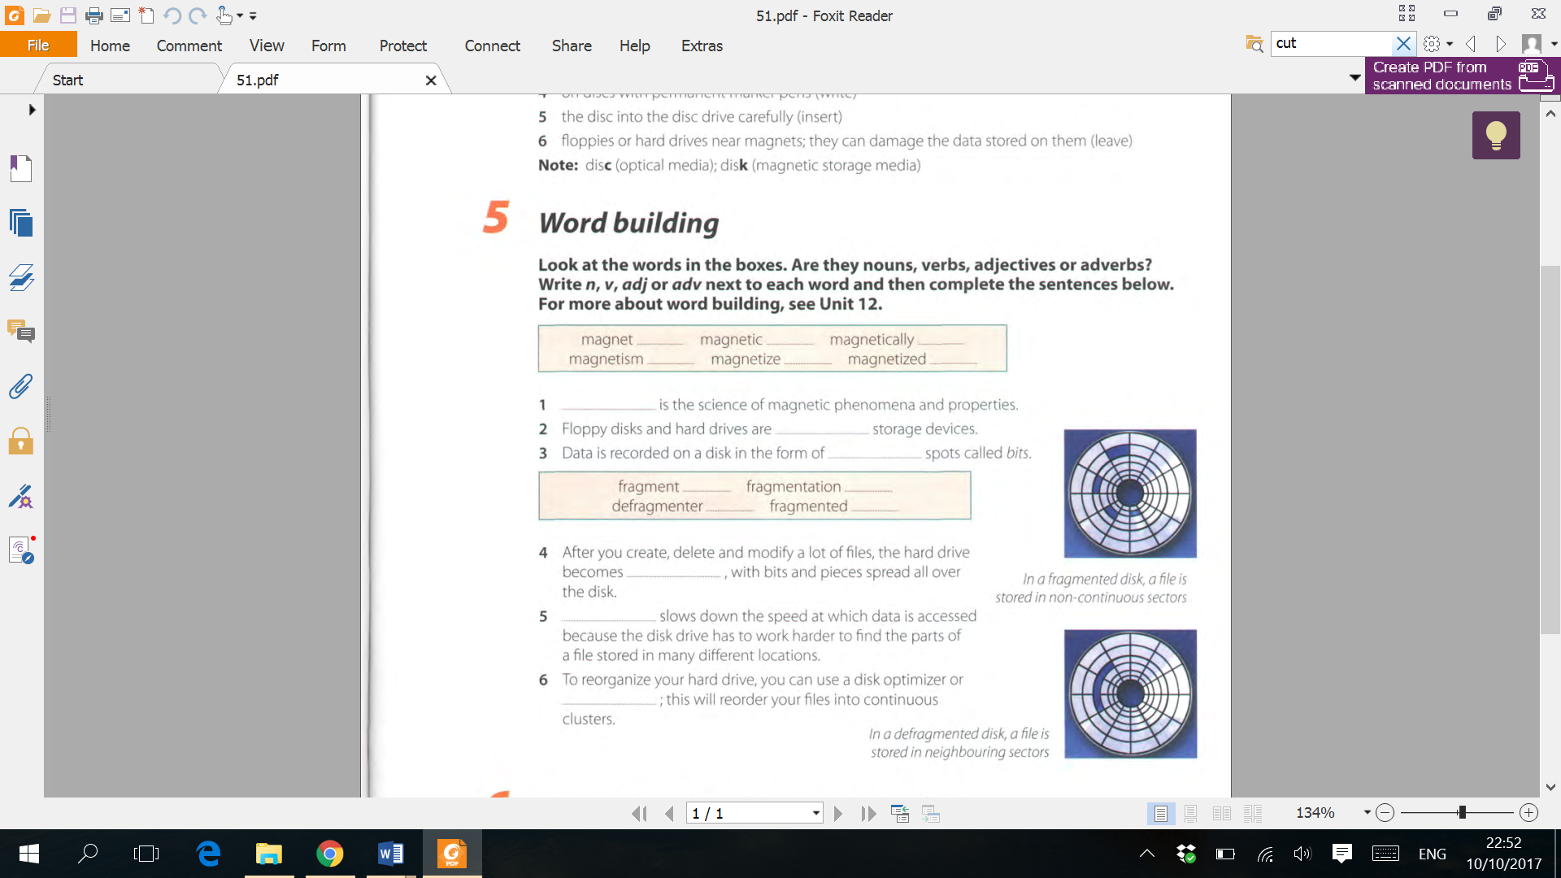

adverb

adverb

verb

noun

noun

verb

verb

noun

adjective

noun

Defragmenter

Fragmentation

Fragmented

Magnetized

Magnetic

Magnetism